Kaupapa Māori Adaptation Wānanga Toolkit
A curated list of wānanga and hui formats to support kōrero about local climate experiences, aspirations, and planning.


Includes facilitation tips, tikanga considerations, and suggested discussion prompts.

Hui steps | Tools and engagement | Description
Information sharing | - Prepare hui pamphlets  - Establish online or in person event  - Location will determine layout and technology requirements  - Print out of workshop materials or present on screen | Develop key questions for whānau to consider before hui e.g. what are the key climate risks? What should we prioritise? How would you like to see decisions being made? What changes would you like to see? What tools are needed to inform decisions? What are some restrictions to the way you are engaged?
Workshop to identify key priorities and inform project plan | Through workshops, try to:  - Develop key focus areas based on research and rangahau  - Identify key issues and drivers for climate change and adaptation relevant to the area  - identify key objectives tangata whenua want to achieve  - Be clear about climate hazards and the atua Maori that have an influence over taiao in the area | Identify through wānanga and rangahau key focus areas to split whānau into groups.  Through workshops with whānau and participants, develop scenarios to test thinking and solutions for climate adaptation plan.
Gathering feedback and themes | - Ensure information shared through previous phases  - Gather key insights and themes  - Report back through additional hui, email, newsletter, Facebook or other method | Ensure a feedback process is provided for hui participants to add and review korero shared and gathered through engagement.

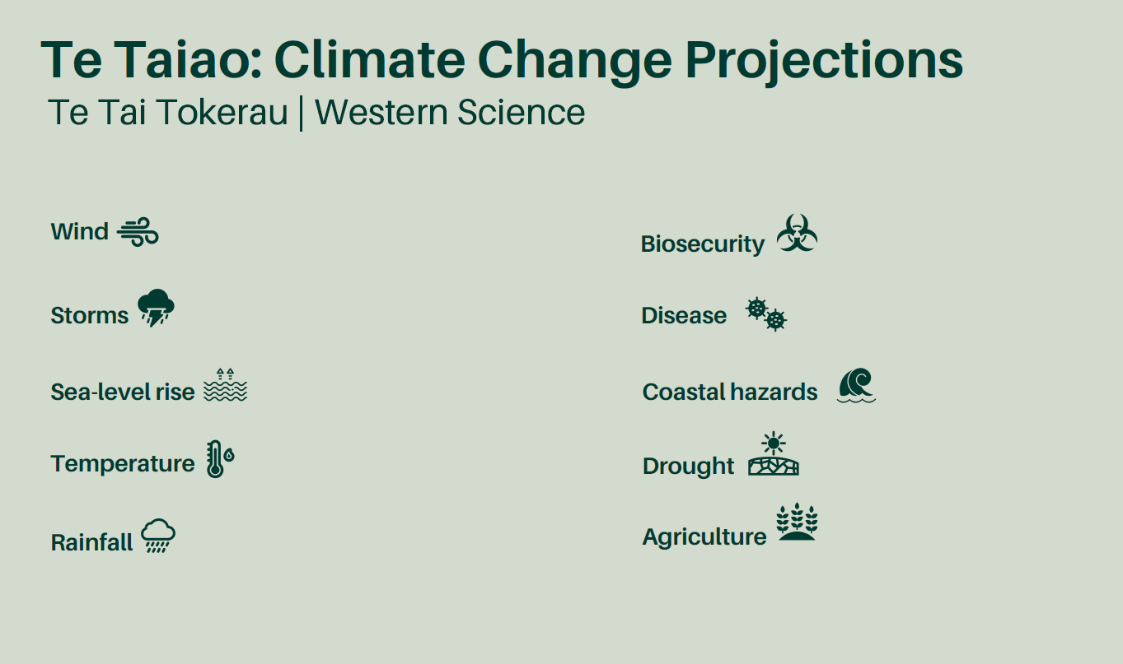
Use western science and information as well as mātauranga from hapū to inform engagement.

Key engagement questions to inform the process:
- Whātoro atu: Reach out. How will you reach out and connect with participants?
- Whakamanea te hunga whaipānga: Attract partners, stakeholders. How will you attract participants?
- Whakamōhio: Inform. How and what will you use to inform everyone?
- Whakawhiti korero: Shared dialogue. How will you have dialogue with the audience?
- Whiriā: Bind and Activate. How will you bind and activate the korero shared?
- Arotake. - Evaluate and review. How will you evaluate and review the analysis of engagement?
- Whakahoki korero: Feedback. How will you feedback the evaluation and analysis of the engagement

