Kaupapa Māori GIS Mapping Guide
A practical resource to support the set-up and use of GIS platforms in kaupapa Māori-based climate planning.
Includes technical and tikanga guidance for using spatial tools to map climate hazards across the rohe.
What is ArcGIS Online?
Introduction to ArcGIS Online: ArcGIS Online is a robust web-based mapping and analysis tool developed by Esri. It allows users to create, share, and manage maps and spatial data in an intuitive and user-friendly interface. With its wide range of features and capabilities, ArcGIS Online has become a popular choice for individuals, organizations, and businesses looking to visualize and analyse spatial data. ArcGIS maps can be used to create relevant layers to help tangata whenua assess areas and cultural assets and infrastructure at risk to natural hazards. A guide for developing an ArcGIS map: https://www.canva.com/design/DAGeHIHq54g/5HaIr7ifziP8b_mv1nRu7g/view?utm_content=DAGeHIHq54g&utm_campaign=designshare&utm_medium=link2&utm_source=uniquelinks&utlId=h70bbc8fc2b
Features and Capabilities:
- Customisation and Flexibility: ArcGIS Online allows users to customise their maps with their branding, styles, and layouts, providing flexibility to meet specific project needs.
- Data Collection and Integration: The platform supports the collection and integration of various types of data, including field data, satellite imagery, and historical maps, allowing for comprehensive analysis and visualization.
- Data Layers: Users can add various layers, including imagery, terrain, and demographic data, to create detailed and informative maps.
- Data Analysis: The platform provides advanced analysis tools for spatial analysis, such as buffering, overlay analysis, and proximity analysis, allowing users to gain deeper insights from their data.
- Collaboration: Users can collaborate and share maps with team members and stakeholders.
- Integration: ArcGIS Online integrates with other Esri products for seamless data sharing and analysis.
- Templates: The platform offers templates and tutorials to help users get started and create professional-looking maps.
- Scalability and Accessibility: ArcGIS Online is scalable, meaning it can accommodate projects of different sizes, from small-scale community mapping to large-scale regional planning. It also offers accessibility features to ensure that maps can be easily understood by all users.
- Cost-Effectiveness: While ArcGIS Online offers a range of features, it is also cost-effective, particularly for smaller organisations or projects that may not have the resources for more complex GIS solutions.
- Data Security: ArcGIS Online includes features for data security and privacy, ensuring that sensitive information is protected and only accessible to authorised users.
- Environmental Monitoring: ArcGIS Online can also be used for environmental monitoring and management, allowing users to track changes in landscapes over time and assess the impact of human activities on cultural and natural resources.

Benefits for Cultural Mapping:
- ArcGIS Online enables the creation of accurate and culturally sensitive maps for cultural mapping purposes.
- Integration of traditional Māori knowledge with modern mapping techniques allows for the reflection of the wider cultural landscape.
- The platform allows for the visualisation of cultural data in a spatial context, enhancing understanding and decision-making
Best Practices:
- Establish clear guidelines for data collection, storage, and sharing to protect sensitive information.
- Establish and respect protocols and ethical considerations associated with mapping sensitive sites.
- Regularly update and maintain maps to ensure accuracy and relevance.
- Use standardised symbols and legends to ensure consistency and clarity in your maps.
- Consider the accessibility of maps for different audiences, including those with varying levels of technical expertise.
Case Studies:
There are many successful examples of cultural mapping projects using ArcGIS Online. The TPK Marae Maps are shared as an example: https://hub.arcgis.com/maps/TPK::map-marae/explore
The Te Puni Kōkiri Marae Map showcases the integration of traditional Māori knowledge with modern mapping techniques using ArcGIS Online. This project maps marae locations along with relevant details (or metadata) such as the marae name, iwi, hapū and other details. Providing valuable insights into the spatial distribution of marae and their role as cultural hubs within the communities. It exemplifies how mapping technology can be utilised to identify significant areas demonstrating the benefits of ArcGIS Online for cultural mapping projects.
Resources and Support:
ArcGIS Online offers extensive resources and support to assist users. The platform provides help documentation and tutorials that guide users through the mapping process. For specific resource links, refer to the following sections of the document. Additionally, there are community forums and user groups where users can seek advice and assistance from other users.
A Beginner's Guide to Mapping in ArcGIS Online:
Mapping in ArcGIS Online offers a powerful set of tools for beginners to transform raw data into compelling maps and meaningful insights. This beginner's guide takes you through the process of data visualization and sharing using ArcGIS Instant Apps or adding a narrative using ArcGIS StoryMaps. Starting from the basics, you will learn how to create maps that convey information effectively and engage your audience. This guide introduces you to the key features of ArcGIS Online, from creating simple maps to performing advanced spatial analysis. Whether you are new to GIS or looking to expand your skills, this guide will help you unlock the full potential of ArcGIS Online for your mapping projects.
This specific resource provides guidance through four stages, including:
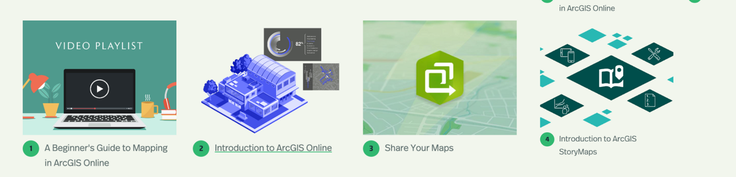
The screenshot below demonstrates the video tutorials available in Stage 1 of the Beginner's Guide to Mapping in ArcGIS Online:
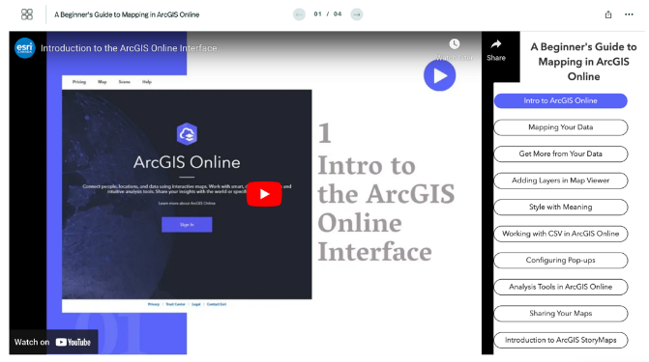

Resource link: https://storymaps.arcgis.com/collections/375ac2dcdede4321bfbc6ebe79c689a7
Cultural Perspectives in GIS Mapping: Māori Ethics & Guiding GIS Mapping Practices
Mapping cultural sites from a Māori perspective involves more than just drawing lines on a map; it requires a deep understanding and respect for the interconnectedness of the environment and the dynamic nature of these sites. This section delves into how Māori ethics guide GIS mapping practices, highlighting the significance of fluid representations, cultural narratives, and ethical considerations in accurately representing culturally significant sites. Outlined below are critical aspects to be reviewed, considered, and applied when mapping culturally significant sites:

- Site Extent: From a Māori perspective, mapping site extents transcends the limitations of rigid lines and fixed boundaries traditionally seen on maps. Instead, it embraces fluid representations, aligning seamlessly with a holistic understanding of the environment. This approach is imperative for several pivotal reasons:
- Whakapapa and Interconnectedness: The land, water, and sky are interconnected through whakapapa, representing genealogical relationships and connections. Fluid mapping extends beyond discrete boundaries, acknowledging the symbiotic relationship between cultural sites, natural features, and spiritual dimensions.
- Dynamic Nature of Cultural Sites of Significance: Māori cultural sites are not static; rather, they are an extension of a living culture and hapū. Fluid mapping representations allow for a nuanced portrayal of the dynamic nature of these sites, reflecting changes in cultural use and significance.
- Cultural Narrative Preservation: The fluid representation on maps allows for the integration of rich and multifaceted cultural narratives, ensuring that the cultural story associated with each site is preserved and communicated effectively.
- Inclusive Protection Measures: Implementing a 20-meter buffer zone for protection ensures the safeguarding of culturally significant sites, acknowledging their interconnectedness with their surroundings.
Site Extent Methodology (Case Study):
The "Sites of Significance Methodology Report" by Des Kahotea PhD is a comprehensive document detailing one approach and methodology for identifying and mapping culturally significant sites. It includes guidelines, procedures, and criteria for determining the cultural extent of sites. (Link: https://wdcsitefinity.blob.core.windows.net/sitefinity-storage/docs/default-source/your-council/plans-policies-and-bylaws/plans/district-plan-review/section-32-reports/tangata-whenua/appendix-11-3-maaori-sites-of-significance-methodology.pdf?sfvrsn=9a2b80c9_2)
Mapping Techniques:
- GIS Mapping: Utilise ArcGIS Online to create a detailed spatial representation of the site, integrating traditional symbols with cultural significance to represent cultural zones and features such as pā, wāhi tapu, etc.
- Contour Mapping: Follow the natural contours of the landscape to authentically capture the essence of the cultural landscape, ensuring the preservation of the environment's integrity.
- Aerial Mapping: Utilise aerial mapping techniques, such as satellite imagery, to gain a comprehensive and bird's-eye view of the cultural site, providing additional perspectives for a more holistic mapping representation.
Ethical Considerations:
- Incorporating Māori Perspectives: The integration of Māori perspectives into the mapping process ensures that cultural authenticity is preserved and respects the interconnectedness embedded in the Māori worldview.
- Prioritisation of Informed Consent: Obtaining consent from individuals and/or kāhui kaumatua (tribal elders) is mandatory in the mapping process to ensure legitimacy and avoid potential harm by disregarding the rights of the hapū.
- Upholding Intellectual Property and Data Sovereignty: Respecting intellectual property and data sovereignty is an obligation that mapping practitioners must fulfil to prevent unauthorised use or exploitation of culturally sensitive information.
Map Disclaimer Note:
A disclaimer can be added to a map for several reasons. It serves to clarify the nature of the boundaries depicted on the map, particularly for culturally significant sites, which may have varying and nuanced boundaries. Including the disclaimer in a prominent location, such as the legend, key, or notes section, ensures that users are aware of the information and understand its significance. It should be presented in a clear and easily readable format. Additionally, the disclaimer could be included in any accompanying documentation or digital resources related to the map to provide further context and guidance. A templated disclaimer text is available below.

Disclaimer: The boundaries of culturally significant sites depicted on this map are indicative and of a varying nature, encompassing elements of time, historic context, and cultural significance. They do not necessarily end at the site's exterior lines. These boundaries are approximate and serve to provide a general understanding of the site's location and significance within the wider cultural landscape. While efforts have been made to ensure the accuracy of the information presented, it is advised to consult Ngāti x kaitiaki and cultural advisors for precise boundary information and cultural protocols. Additionally, users are encouraged to exercise caution and sensitivity when visiting or interacting with these sites to respect their cultural significance and uphold ethical standards. This map is part of the wider cultural landscape and serves as a tool to enhance understanding and appreciation of these sites. The creators of this map are not liable for any misinterpretation or misuse of the information provided.

Ngā Poutama Matawhenua: Māori GIS Mapping Wānanga Webinar Series
Ngā Poutama Matawhenua Practical Māori GIS Mapping Wānanga webinar series is a resource designed to provide practical training in GIS mapping from a Māori perspective. The series likely offers webinars focused on hands-on learning and application of GIS tools and techniques tailored for Māori individuals and groups, such as iwi, Māori trusts, and environmental organisations. It aims to help participants learn how to map their whenua (land) and tell their stories through GIS mapping, integrating traditional Māori knowledge and contemporary mapping methods.
All the videos listed on the Toitū Te Whenua Land Information New Zealand YouTube channel under the "Ngā Poutama Matawhenua" playlist are available to the public. These videos cover a range of topics related to GIS mapping and are designed to help individuals learn how to map their whenua and tell their stories through GIS mapping. Here are some examples of the videos available in the "Ngā Poutama Matawhenua" playlist:
- "GIS Data for Māori trusts and environmental groups working in the marine environment": This video likely provides guidance on accessing and utilising GIS data for marine-related projects.
- "Aotearoa New Zealand datasets on the ArcGIS Living Atlas of the World": This video likely introduces viewers to datasets available on the ArcGIS Living Atlas of the World related to New Zealand, showcasing the types of data that can be utilised for mapping projects.
- "StoryMaps to support marae and whenua funding applications": This video likely demonstrates how to use StoryMaps for creating compelling narratives to support funding applications related to marae and whenua projects.
- "GIS mapping tools to support whānau & understand changes in the whenua during extreme weather events": This video likely showcases GIS mapping tools that can be used to analyse and understand changes in the whenua (land) during extreme weather events, helping whānau (family) make informed decisions.
These videos serve as examples of the diverse range of topics covered in the "Ngā Poutama Matawhenua" playlist, providing valuable guidance and insights for those interested in GIS mapping.
Link to Youtube Playlist of Ngā Poutama Matawhenua Tutorials:
https://www.youtube.com/playlist?list=PLyE56PxGCqSXGUtFIvpNn0b_SauF4XfIk
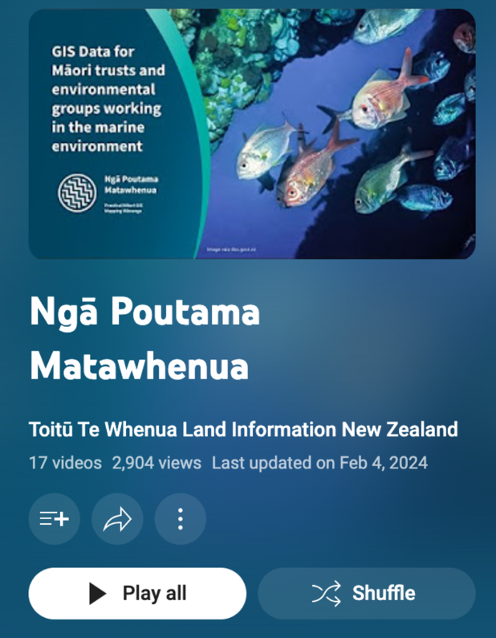

Below are specific Ngā Poutama Matawhenua online tutorials that are of value when undertaking the GIS mapping of culturally significant sites.

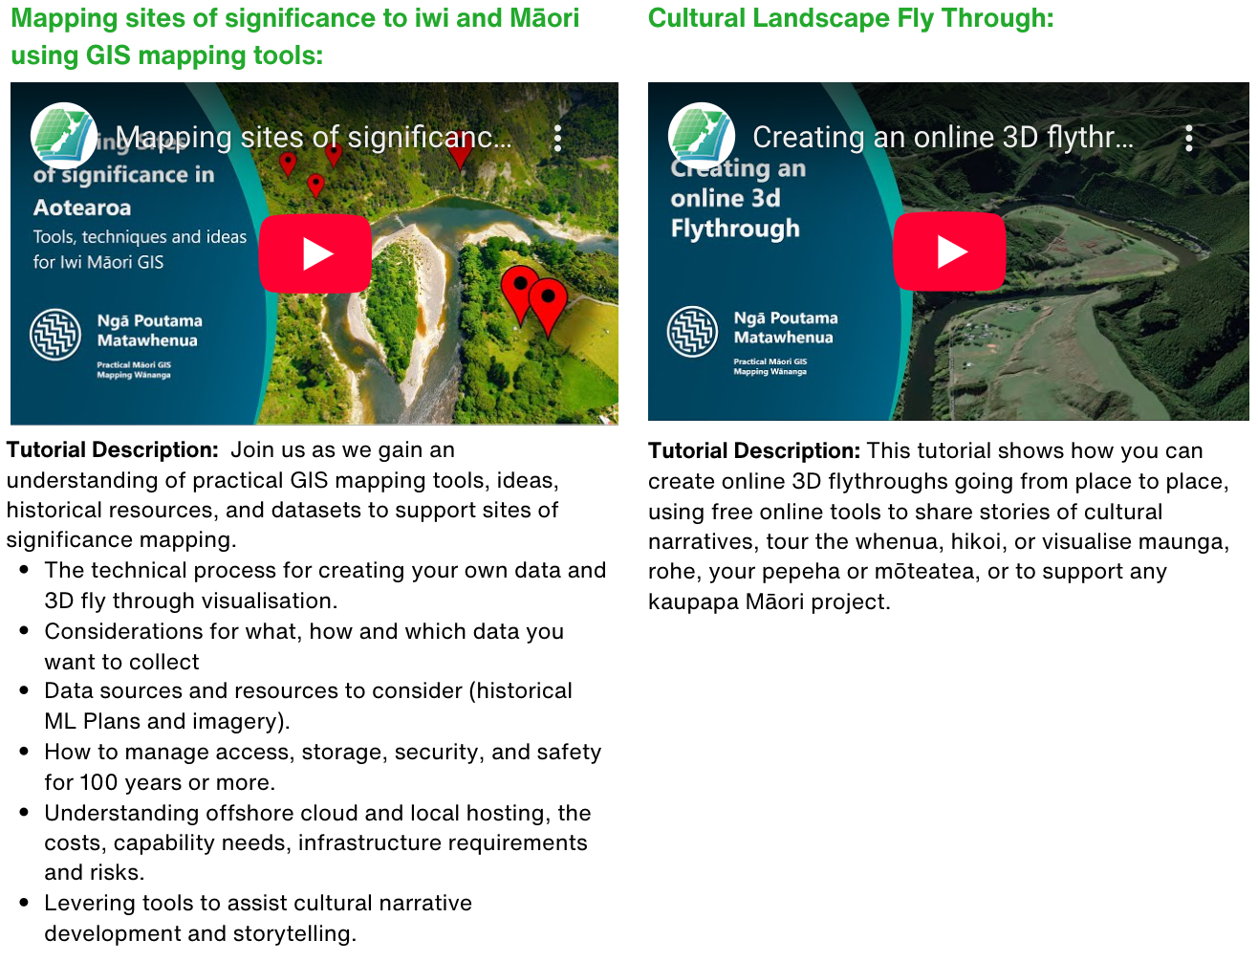

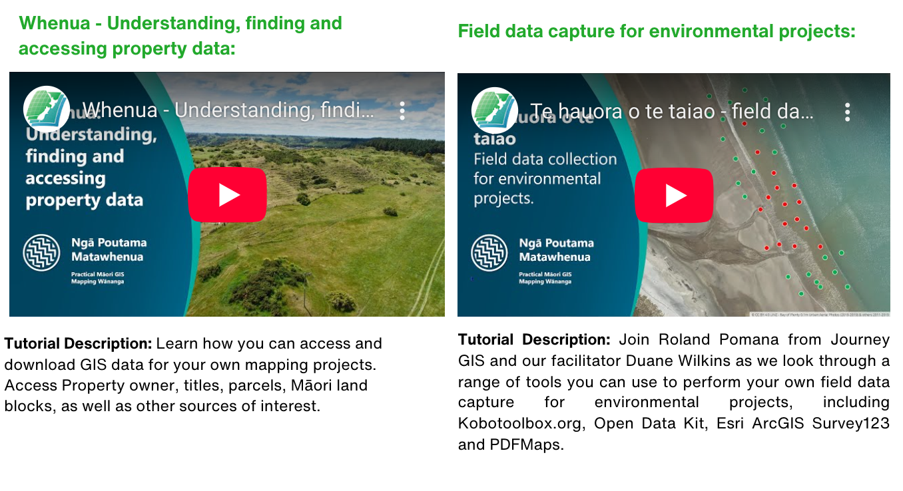
GIS Data Layers
The table below provides links to relevant GIS layers for building GIS maps with multiple data sources to aid in identifying and managing the cultural landscape.

Please note that the information provided in this table is not exhaustive and may not encompass all available public data sources. Additional data sources and information may be available for mapping and monitoring sites of cultural significance.

Core Data Sources:
LINZ Data Service | https://data.linz.govt.nz/
Far North District Council Open Data (Far North District Plan Overlays) | https://opendata-fndc.hub.arcgis.com/
Māori Land Court Data | https://www.maorilandcourt.govt.nz/your-maori-land/maori-land-data-service/#spatial-data
MfE Data Service | https://data.mfe.govt.nz/
Manaaki Whenua Data Service | https://lris.scinfo.org.nz/
Stats Datafinder | https://datafinder.stats.govt.nz/
Department of Conservation GIS Maps | https://www.doc.govt.nz/our-work/maps-and-data/
Te Puni Kōkiri | https://www.arcgis.com/home/user.html?user=tpkmaps
https://Tupu.nz | https://www.tupu.nz/
NIWA | https://data-niwa.opendata.arcgis.com/search
NZTA | https://opendata-nzta.opendata.arcgis.com/
data.govt.nz | https://data.govt.nz/
ArchSites | https://nzarchaeology.org/archsite

Relevant Layers
Historical Imagery Sources and Environmental Monitoring | Retrolens.nz (B&W aerials from 1936) | https://retrolens.co.nz/
Historical Imagery Sources and Environmental Monitoring | Esri Wayback service (Satellite from ~2010s accurately geolocated+GIF export) | https://livingatlas.arcgis.com/wayback/#active=13968&mapCenter=-115.29850%2C36.06400%2C13
Historical Imagery Sources and Environmental Monitoring | Google Earth Pro Desktop Historical Satellite and Landsat Imagery. | https://www.google.com/earth/about/versions/
Historical Imagery Sources and Environmental Monitoring | Google Earth Timelapse | https://earthengine.google.com/timelapse/
Historical Imagery Sources and Environmental Monitoring | LINZ Data Service Imagery (online, download or as a webservice). | https://data.linz.govt.nz/data/category/aerial-photos/
Historical Imagery Sources and Environmental Monitoring | LINZ Orthophotos: | https://data.linz.govt.nz/data/?q=orthophotos
Historical Imagery Sources and Environmental Monitoring | LINZ BaseMaps: | https://basemaps.linz.govt.nz/@-41.8899962,174.0492437,z5
Historical Imagery Sources and Environmental Monitoring | Google Earth: Te Puni Kōkiri | https://www.google.com/earth/about/gallery/
Historical Imagery Sources and Environmental Monitoring | Google Earth Timelapse Aoraki Aotearoa | https://earth.google.com/web/@-43.58656727,170.21034233,1168.71110812a,35845.82100525d,35y,-21.21808821h,64.48627256t,0r/data=Cg86DQgBEQAAAAAAAPA_IAE6AwoBMA
Historical Imagery Sources and Environmental Monitoring | New Zealand Gazetteer: This online searchable tool is a repository for Aotearoa New Zealand’s place names. | https://gazetteer.linz.govt.nz/
The Māori Land Court | Basic Maori Land Spatial Dataset | http://www2.justice.govt.nz/website-documents/mlc/MLC_2017_05-District_Boundaries.zip
The Māori Land Court | Advanced Maori Land Spatial Dataset | http://www2.justice.govt.nz/website-documents/mlc/MLC_2017_05-Geodatabase.zip
The Māori Land Court | Maori Land Court District Boundaries | http://www2.justice.govt.nz/website-documents/mlc/MLC_2017_05-District_Boundaries.zip
Manaaki Whenua Landcare Research | NZLRI Land Use Capability | https://lris.scinfo.org.nz/layer/48076-nzlri-land-use-capability-2021/
Manaaki Whenua Landcare Research | NZLRI Soils | https://lris.scinfo.org.nz/layer/48066-nzlri-soil/
Manaaki Whenua Landcare Research | Land Cover Database V5 | https://lris.scinfo.org.nz/layer/104400-lcdb-v50-land-cover-database-version-50-mainland-new-zealand/
Manaaki Whenua Landcare Research | S-map - Soil spatial information system | https://lris.scinfo.org.nz/layer/48440-s-map-a-new-soil-spatial-information-system-for-new-zealand-2021-deprecated/
Land Information NZ (LINZ Data Service) | Named Rivers | https://data.linz.govt.nz/layer/103632-nz-river-name-lines-pilot/
Land Information NZ (LINZ Data Service) | Latest NZ Aerial Imagery | https://data.linz.govt.nz/set/4702-nz-aerial-imagery/
Land Information NZ (LINZ Data Service) | Primary Parcels | https://data.linz.govt.nz/set/4769-nz-parcel-boundaries-wireframe/
Land Information NZ (LINZ Data Service) | Property Titles | https://data.linz.govt.nz/layer/50804-nz-property-titles/
Land Information NZ (LINZ Data Service) | Access Group for Owner details | https://data.linz.govt.nz/group/owner-data-controlled-access-group
Land Information NZ (LINZ Data Service) | Bathymetric data | https://data.linz.govt.nz/layer/53388-nz-bathymetric-data-index/
Land Information NZ (LINZ Data Service) | Marine Charts | https://data.linz.govt.nz/data/category/hydrographic-maritime/chart-images/
Land Information NZ (LINZ Data Service) | LiDAR elevation | https://data.linz.govt.nz/group/national-elevation/data/category/elevation/?s=r
Land Information NZ (LINZ Data Service) | NZGB Place names | https://data.linz.govt.nz/layer/51681-nz-place-names-nzgb/
Land Information NZ (LINZ Data Service) | Roads | https://data.linz.govt.nz/layer/53382-nz-roads-addressing/
Land Information NZ (LINZ Data Service) | LINZ Managed crown property | https://data.linz.govt.nz/layer/53358-linz-managed-crown-property/
Land Information NZ (LINZ Data Service) | Protected Areas | https://data.linz.govt.nz/layer/53564-protected-areas/
Land Information NZ (LINZ Data Service) | https://basemaps.linz.govt.nz | https://basemaps.linz.govt.nz
Land Information NZ (LINZ Data Service) | https://linz.recollect.co.nz/ | https://linz.recollect.co.nz/
Department of Conservation | DOC Tracks | https://doc-deptconservation.opendata.arcgis.com/datasets/59a193dfa57d4f87b7ef157a412907d3_0/explore
Department of Conservation | Marine Mammal Sanctuaries | https://doc-deptconservation.opendata.arcgis.com/datasets/abf12dd2f4cd43b3a7fdfc5a0a2ad2c9_0/explore
Department of Conservation | Hunting Permit Areas | https://doc-deptconservation.opendata.arcgis.com/datasets/f8fb2864d9a745b59152afb0ea4ca2ae_0/explore
Department of Conservation | Public Conservation Land | https://doc-deptconservation.opendata.arcgis.com/datasets/72354ba9bf7a4706af3fdfe60f86eea1_0/explore
Department of Conservation | DOC Marine Reserves | https://doc-deptconservation.opendata.arcgis.com/datasets/0e74f9682502447c9a14d51340512361_0/explore
Department of Conservation | DOC Ecosystem Management Units | https://doc-deptconservation.opendata.arcgis.com/datasets/2e29f7a4b1f44006a635d3a74fc7e10a_0
Department of Conservation | DOC Campsites | https://doc-deptconservation.opendata.arcgis.com/datasets/c417dcd7c9fb47b489df1f9f0a673190_0/explore
Department of Conservation | Direct DOC Downloads Zip files. | https://ftp.doc.govt.nz/public/folder/xyofNsND-U6Xfl_YtITkyQ/GIS
Ministry for the Environment | Irrigated land area | https://data.mfe.govt.nz/layer/90838-irrigated-land-area-2017/
Ministry for the Environment | Current Wetland Extent | https://data.mfe.govt.nz/layer/52676-current-wetland-extent-2013/
Ministry for the Environment | Indigenous Vegetation Cover | https://data.mfe.govt.nz/layer/52765-indigenous-vegetation-cover-remaining-and-protection-20012012/
Ministry for the Environment | Prediction of wetlands before humans | https://data.mfe.govt.nz/layer/52677-prediction-of-wetlands-before-humans-arrived/
Ministry for the Environment | Bird Species | https://data.mfe.govt.nz/layer/52763-bird-species-on-public-conservation-land-2013/
Ministry for the Environment | Marine Reserves | https://data.mfe.govt.nz/layer/52760-marine-reserves/
Ministry for the Environment | Marine Environment Classification | https://data.mfe.govt.nz/layer/52368-marine-environment-classification-eez-20-classes-2010/
Ministry for the Environment | Land Use 1990-08-12-2016 | https://data.mfe.govt.nz/layer/52375-lucas-nz-land-use-map-1990-2008-2012-2016-v011/
Ministry for the Environment | Vulnerable Catchments | https://data.mfe.govt.nz/layer/53523-vulnerable-catchments/
Ministry for the Environment | Environmental Limiting Factors | https://data.mfe.govt.nz/layer/52374-environmental-limiting-factors-2012/
Ministry for the Environment | Lake water quality trends | https://data.mfe.govt.nz/table/52538-lake-water-quality-trends-2004-2013/
Ministry for the Environment | Fundamental Soil Layers | https://data.mfe.govt.nz/layer/52766-fundamental-soil-layers-new-zealand-soil-classification/
Ministry for the Environment | Erosion Risk North Island | https://data.mfe.govt.nz/layer/53177-erosion-risk-north-island-2012/
Ministry for the Environment | River Environment Classification | https://data.mfe.govt.nz/layer/51845-river-environment-classification-new-zealand-2010/
Ministry for the Environment | River Flows | https://data.mfe.govt.nz/layer/53309-river-flows/
Ministry for the Environment | Location and extent of NZ's aquifers | https://data.mfe.govt.nz/layer/52675-location-and-extent-of-nzs-aquifers-2015/
Statistics New Zealand | District & Regional Councils | https://datafinder.stats.govt.nz/data/?q=Council
Statistics New Zealand | Māori Constituency | https://datafinder.stats.govt.nz/layer/98750-maori-constituency-2019-generalised/
Statistics New Zealand | NEET Māori youths by Area unit 2015 | https://datafinder.stats.govt.nz/layer/87763-neet-maori-youths-by-area-unit-2015/
Statistics New Zealand | Census 2018 Data | https://datafinder.stats.govt.nz/data/category/census/2018/sa1-dataset/sa1/?q=census+2018
Te Puni Kokiri ArcGIS online | Marae | https://www.arcgis.com/home/item.html?id=3b9e52a2012a4e4cb434e07ce19b36dd
Te Puni Kokiri ArcGIS online | Iwi Areas of interest | https://www.arcgis.com/home/item.html?id=1016f88251c5402291c1aa5020aab02d
Te Puni Kokiri ArcGIS online | Māori land blocks vs Land Use Capability | https://www.arcgis.com/home/item.html?id=0bb9d6bafe194f34a72c992833c4a980
Marine Links: | Marine charts for estuaries: | https://data.linz.govt.nz/data/category/hydrographic-maritime/
Marine Links: | Maritime Boundaries | https://data.linz.govt.nz/data/category/hydrographic-maritime/maritime-boundaries/
Marine Links: | 12 Mile Territorial Limit | https://data.linz.govt.nz/layer/50846-12-mile-territorial-sea-outer-limit/
Marine Links: | Named, Sea Draining Catchments | https://www.arcgis.com/home/item.html?id=2cc02f39c5494f87aa72c588c7b3527f
Marine Links: | Bathymetric Index | https://data.linz.govt.nz/layer/53388-nz-bathymetric-data-index/
Marine Links: | NZ Place Names Gazetteer | https://data.linz.govt.nz/data/category/gazetteer/
Marine Links: | For pātai/queries about marine geospatial information from Toitū Te Whenua, email | hydro@linz.govt.nz
Marine Links: | Te Kete Kōrero a Te Takutai Moana | https://maca-nds.maps.arcgis.com/apps/MapSeries/index.html?appid=1ed9665a8d2c4d38b4f9ddcb2d186f1b
Marine Links: | Customary Marine Title areas as recognised under the Ngā Rohe Moana o Ngā Hapū o Ngāti Porou Act 2019 - Overview (arcgis.com) | https://maca-nds.maps.arcgis.com/home/item.html?id=5f73d1e0787842c8896df247331ec32b
Marine Links: | Crown Engagement Application Areas - Overview (arcgis.com) | https://maca-nds.maps.arcgis.com/home/item.html?id=54f7f207afae41019897f1360cdae0b8
Marine Links: | High Court Application Areas - Overview (arcgis.com) | https://maca-nds.maps.arcgis.com/home/item.html?id=c8eb6daf011548d3941b265f8cb5ca07
Marine Links: | DOC Marine Reserves | https://www.arcgis.com/home/item.html?id=0e74f9682502447c9a14d51340512361
Marine Links: | Realtime live Ships | https://www.marinetraffic.com/en/ais/home/centerx:176.8/centery:-38.9/zoom:7

