Atua Māori Whakapapa Resources
A series of visual resources capturing the whakapapa relationships between key atua Māori.
A visual resource showing how atua Māori are connected through whakapapa. Assisting whānau and hapū understand these relationships and use them to interpret tohu and environmental shifts through and whakaaro and tirohanga Māori

Purpose
This resource supports tangata whenua to lead climate adaptation planning by grounding decision-making in whakapapa and mātauranga Māori. It encourages whānau, hapū, and iwi to begin by exploring their own kōrero tuku iho, atua connections, and local mātauranga. The examples provided are sourced from public whakapapa charts to assist those who may need inspiration to start the kōrero.

Examples of Atua Māori Whakapapa & Taiao Relationships
Whakapapa Chart Name | Source | Summary
Papatūānuku’s Children | https://teara.govt.nz/en/whakapapa/11430/papatuanukus-children | Shows how atua like Tāwhirimātea, Tangaroa, and Tāne are descended from Papatūānuku and Ranginui.
Origins of Trees | https://teara.govt.nz/en/whakapapa/11468/origins-of-trees | Details the origin of different trees and plants as descendants of Tāne.
Whakapapa of Rocks and Stones | https://teara.govt.nz/en/document/8877/whakapapa-of-rocks-and-stones | Links different rock types to atua, showing the genealogies of geological formations.
Whakapapa (General Chart) | https://teara.govt.nz/en/whakapapa/13900/whakapapa | A visual summary of the major atua and their descendants in environmental domains.
Whakapapa of Putoto | https://teara.govt.nz/en/whakapapa/9372/whakapapa-of-putoto | Shows the relationships between atua and intestinal organs, representing internal systems of living beings.
Tangaroa’s Descendants | https://teara.govt.nz/en/whakapapa/7952/tangaroas-descendants | Explores Tangaroa’s many offspring that inhabit the oceans and inland waters.
Fish Genealogy | https://teara.govt.nz/en/document/7389/fish-genealogy | A whakapapa of various fish types as descendants of Tangaroa.
Genealogy of the Winds | https://teara.govt.nz/en/whakapapa/8274/genealogy-of-the-winds | Traces the origins of different winds and their connection to Tāwhirimātea.
The following videos are part of a series of resources designed to support understanding of atua Māori through pūrākau (traditional stories) and cultural narratives.
Each video brings these cultural narratives to life, offering insight into the Māori worldview, including themes of creation, connection, knowledge, and identity. These narratives are vessels of mātauranga Māori (Māori knowledge), assisting tangata whenua to explore the deep relationships between people, the natural world, and atua Māori.
The Māori Gods: The Beginning of the Universe | 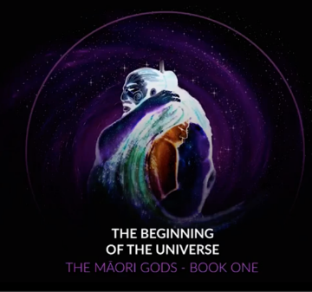
Ngā Atua Māori: Te Wehenga o Ranginui rāua ko Papatūānuku | 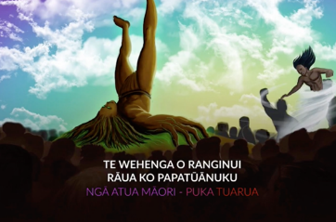
The Māori Gods: The Battle at Te Paerangi | 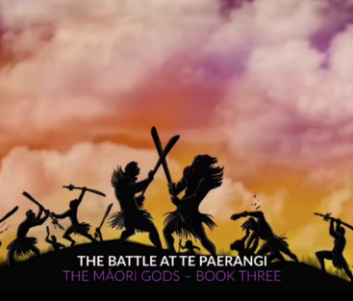
The Māori Gods: Tāne and the Baskets of Knowledge | 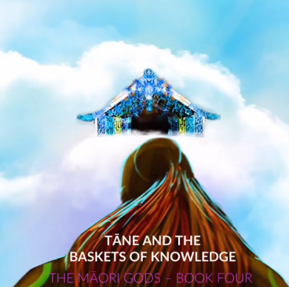

Tips for Using in Climate Planning
Use these whakapapa examples to complement your local mātauranga. They can be printed, displayed at wānanga, or incorporated into your visual storytelling. Where possible, adapt them to reflect your own hapū-specific pūrākau. Encourage open kōrero and creative expression.

Workshop Prompts
Begin with a wānanga session inviting whānau to share their whakapapa of the taiao. Use the following questions to prompt kōrero:
- What atua do you associate with our whenua, awa, or moana?
- What pūrākau have been handed down about environmental change or guardianship?
- Who are the kaitiaki that guide your actions in times of change?

