Creative Communities Scheme
Project completion Report form

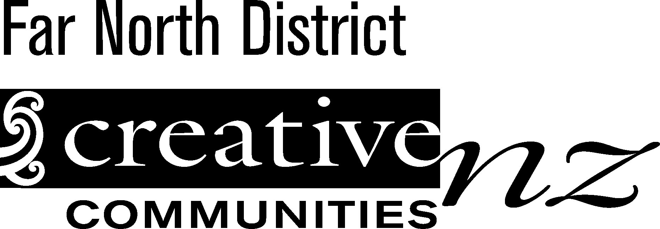
All recipients of funds from the Creative Communities Scheme must complete this form within two months after their project is completed.
If you do not complete and return this form you will not be eligible for future funding through this scheme.

Please return the completed form to –
Far North District Council
Funding Advisor
Private Bag 752
KAIKOHE

- Project title/grant number

- Name of applicant

- Name & location of project

- Date of Project
- Amount received from the Creative Communities scheme
$

- Please give details of how the money was spent. Please account for both the Creative Communities Scheme funding and your own financial contribution to the project.

Project Costs
Item | Detail | Amount
e.g Hall Hire | e.g 3 days hire at $100.00 per day | e.g $300.00
 |  | $
 |  | $
 |  | $
 |  | $
 |  | $
 |  | $
 |  | $
 |  | $
 |  | $
 |  | $
 |  | $
A : Total Cost |  | $

Item | Detail | Amount
e.g Ticket Sales | e.g 250 tickets at $15 per ticket | e.g $3750.00
 |  | $
 |  | $
 |  | $
 |  | $
 |  | $
 |  | $
 |  | $
 |  | $
 |  | $
 |  | $
 |  | $
B : Total Income |  | $
Project Income

- How many people?
- Write down the numbers of people that
actively participated
- Write the number of people that
attended (such as the audience members)

- Highlights: Give a brief description of the highlights of your project. Also describe what didn’t work so well and what you might do differently next time?

- How did your project benefit your community?

This report was completed by:

